**Faculty Profile**

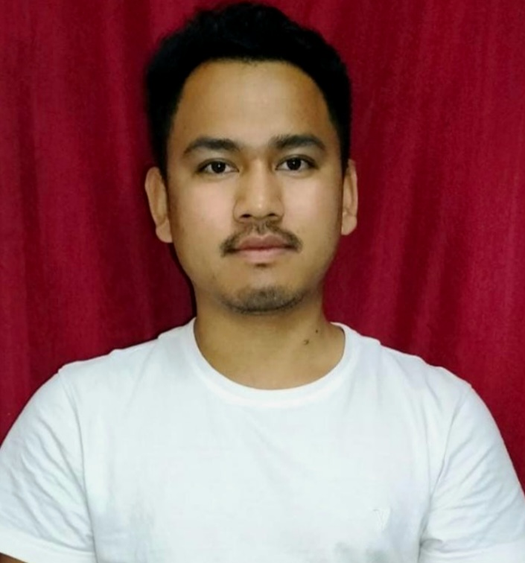

Name : Salpa Jamatia

Qualification : Master in Arts(MA)

Designation : Guest Lecturer

Department : Political Science

Specialization: Political Science

Address for Communication: Amaresh Para, Karbook, Gomati, Tripura

Contact No. **: 8974776095**

Email : salpajamatia5@gmail.com

Date of Joining : 4th November,2023

Year of Experience :-

**Academic and Administrative Responsibilities :**

|  |  |  |  |
| --- | --- | --- | --- |
| **Sl.No** | **Titles** | **Institution** | **Year** |
|  |  |  |  |
|  |  |  |  |
|  |  |  |  |
|  |  |  |  |
|  |  |  |  |
|  |  |  |  |
|  |  |  |  |
|  |  |  |  |
|  |  |  |  |

**Publication Details**:

**Seminar Proceedings/ Books/ Articles in Edited Books**

|  |  |  |  |
| --- | --- | --- | --- |
| **Sl.No** | **Titles** | **Publisher** | **Month and Year** |
|  |  |  |  |
|  |  |  |  |
|  |  |  |  |
|  |  |  |  |
|  |  |  |  |
|  |  |  |  |

**Publication Details**:

**Seminar Proceedings and Journals( with ISBN/ISSN)**

|  |  |  |  |
| --- | --- | --- | --- |
| **Sl.No** | **Titles** | **Publisher** | **Month and Year** |
|  |  |  |  |
|  |  |  |  |
|  |  |  |  |

**Review paper for National/ International Journal / Conferences:**

|  |  |  |  |  |
| --- | --- | --- | --- | --- |
| **Sl.No** | **Title of the Paper** | **Name of Journal** | **Date & Month of the Reviewed** | **Review feedback/ Certificate** |
|  |  |  |  |  |
|  |  |  |  |  |
|  |  |  |  |  |

**Paper Presented at National/ International Seminars / Conferences:**

|  |  |  |  |  |
| --- | --- | --- | --- | --- |
| **Sl.No** | **Title of the Paper Presented** | **Seminars / Conferences Attended** | **Duration/ Date** | **Organised by** |
|  |  |  |  |  |
|  |  |  |  |  |
|  |  |  |  |  |

**Delivered Invited Lectures at Symposiums/ Workshops/ Training Programmes:**

**Chaired at Seminars/ Conferences/ Workshops:**

|  |  |  |  |  |
| --- | --- | --- | --- | --- |
| Sl.No | Title of Lecture | Programme | Date | Place |
|  |  |  |  |  |
|  |  |  |  |  |
|  |  |  |  |  |

**Participated at National/ International Seminars / Conferences / Workshop / Webinar:**

|  |  |  |  |
| --- | --- | --- | --- |
| Sl. No | Title of the Conference/Seminar/Workshop/Webinar | Organized by | Whether International/National/State/Regional/University/ College level |
|  |  |  |  |
|  |  |  |  |

**Organized Conferences, Seminars, Workshops, Symposia, Lecture Series, Webinar, etc**

|  |  |  |  |  |
| --- | --- | --- | --- | --- |
| Sl. No | Title of the Conference/Seminar/Workshop/Webinar | Organized by | Whether International/National/State/Regional/University/ College level | Organizing Secretary/Convener |
|  |  |  |  |  |
|  |  |  |  |  |
|  |  |  |  |  |

**Attended Faculty Development Programmes/OP/RC/ Summar School, etc:**

|  |  |  |
| --- | --- | --- |
| **Sl.No** | **Programmes** | **Details** |
|  |  |  |
|  |  |  |

**Research Achievements:**

|  |  |  |  |
| --- | --- | --- | --- |
| Sl. No | Title of the Project (MRP/ Major) | Funding Agency | Remarks |
|  |  |  |  |
|  |  |  |  |

**Membership/Positions in National/ International Academic Bodies/ Organisations:**

**If any……**